**Laravel Assignment: Building a Simple Blog Application**

Create a simple blog application using Laravel that demonstrates your understanding of database migrations, models, routes, and views.

**Step 1: Set Up Your Laravel Project**

1. **Install Laravel**
   * Use Composer to create a new Laravel project:

composer create-project laravel/laravel blog

* + **Screenshot:** Terminal after running the command.

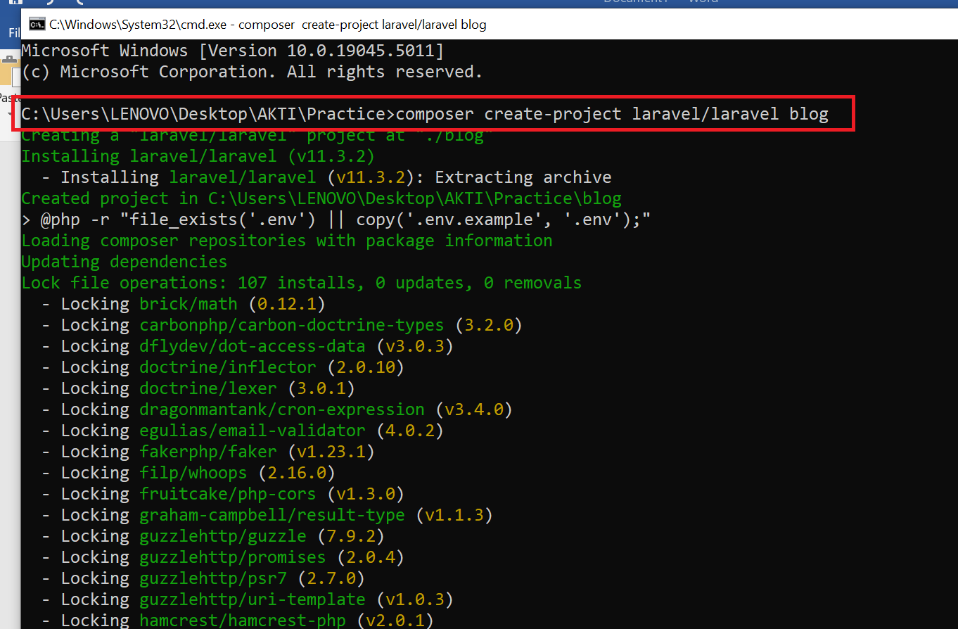

1. **Navigate to Your Project Directory**

cd blog

**Step 2: Database Configuration**

1. **Configure Database**
   * Open the .env file in your project root and set up your database credentials before setting make sure your database is up and running:

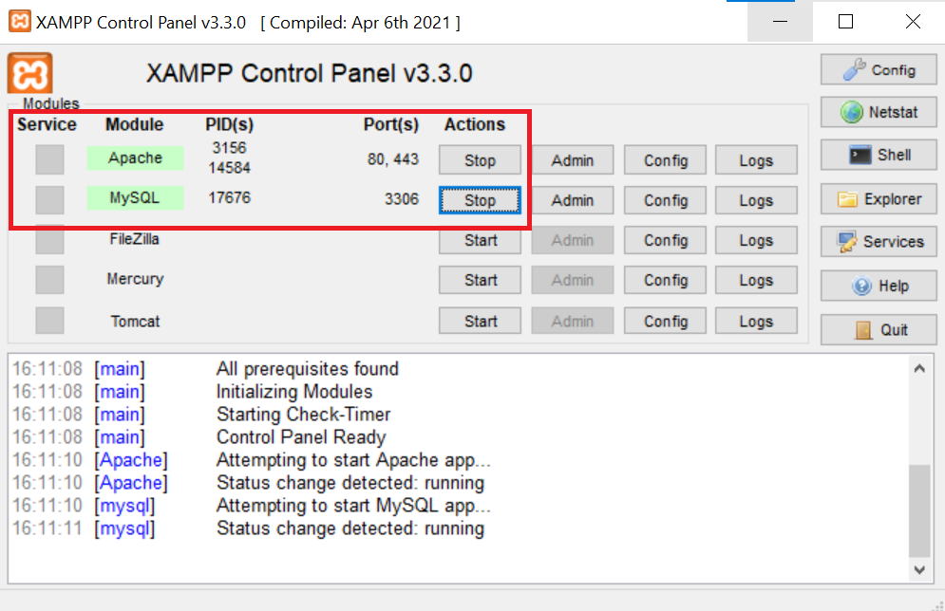

* + **Screenshot**: .env file with the database settings.

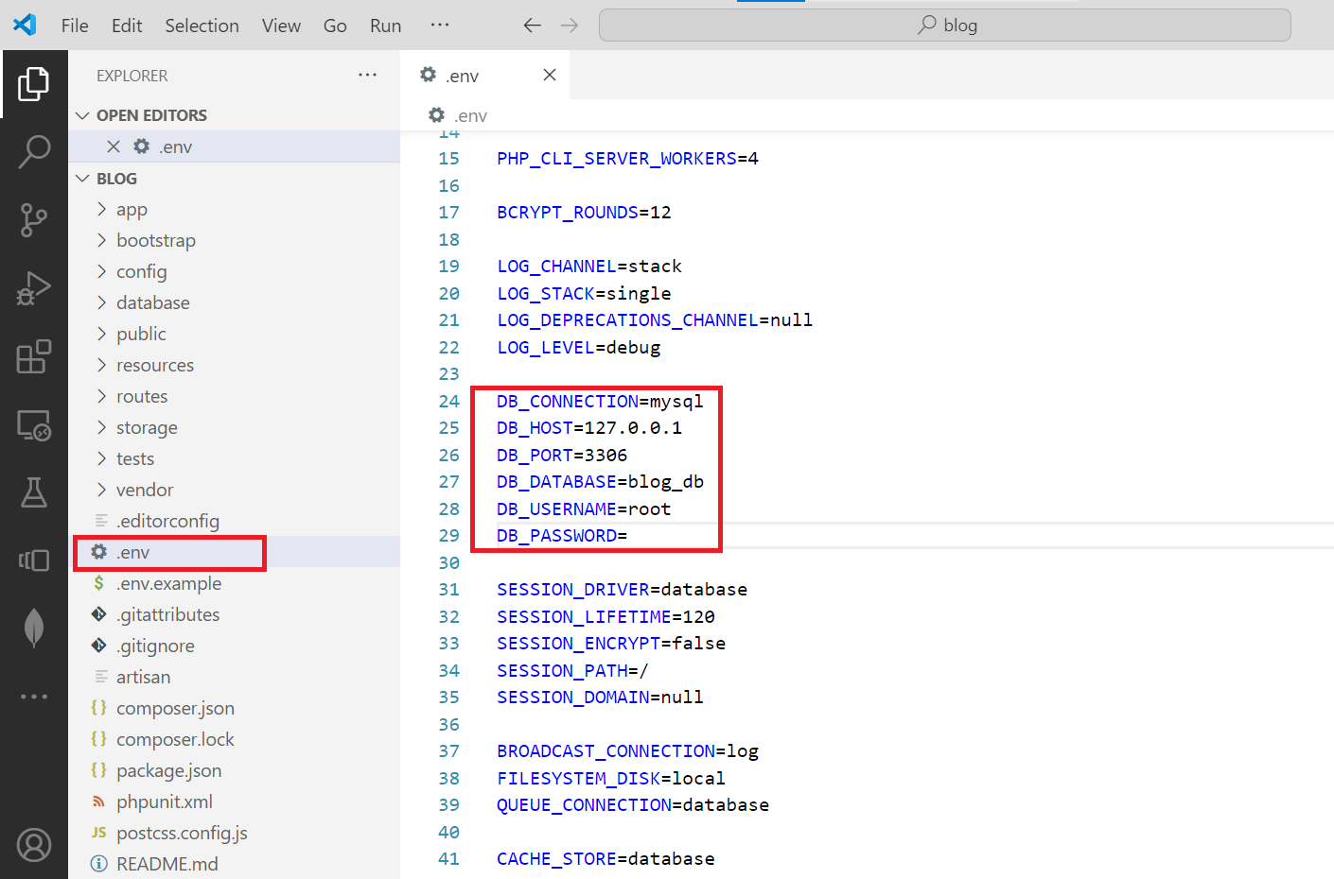

**Step 3: Create the Migration for Posts Table**

1. **Create Migration**
   * Run the following command to create a migration for the posts table:

php artisan make:migration create_posts_table --create=posts

* + **Screenshot**: Show the terminal after running the command.

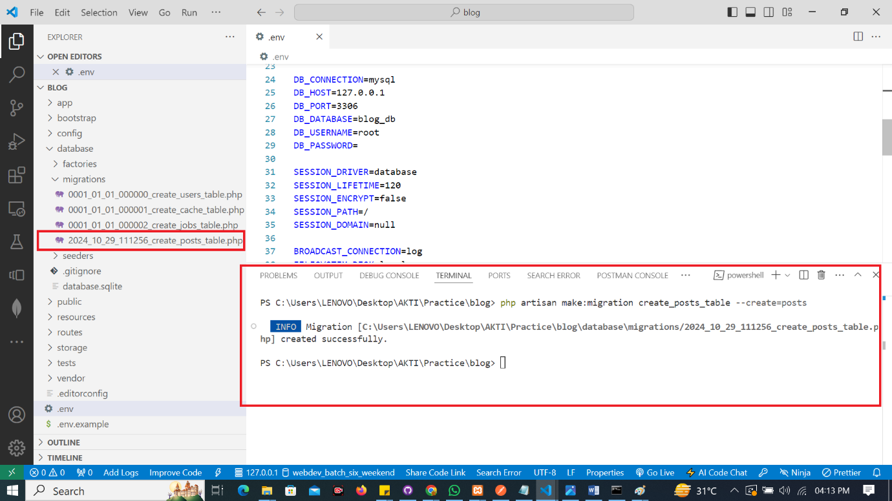

1. **Define the Schema**
   * Open the newly created migration file in database/migrations/ and define the schema:

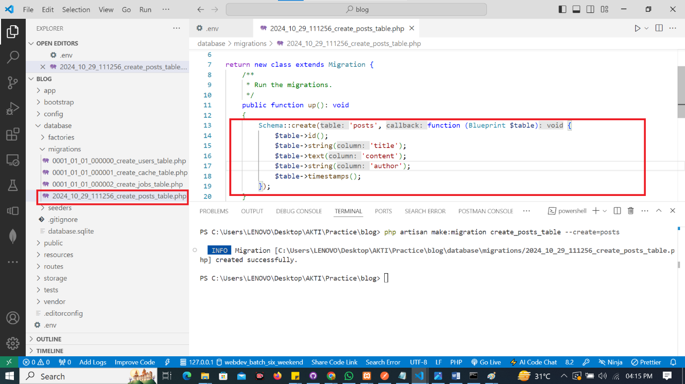

1. **Run the Migration**
   * Execute the migration to create the table:

php artisan migrate

* + **Screenshot**: Terminal confirming the migration.

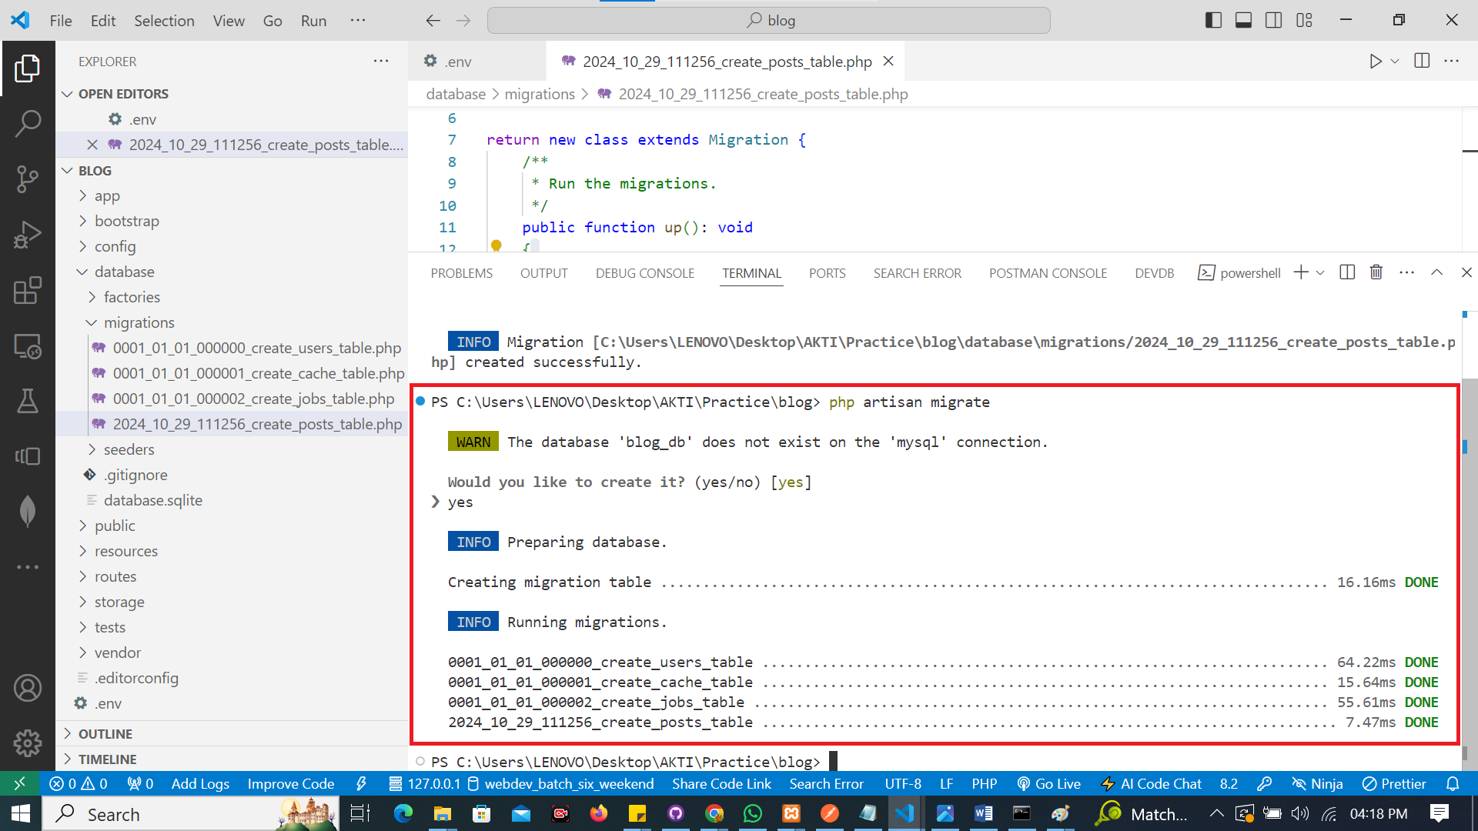

**Step 4: Create the Post Model**

1. **Create the Model**
   * Run the command to create a model:

php artisan make:model Post

* + **Screenshot**: After running the command.

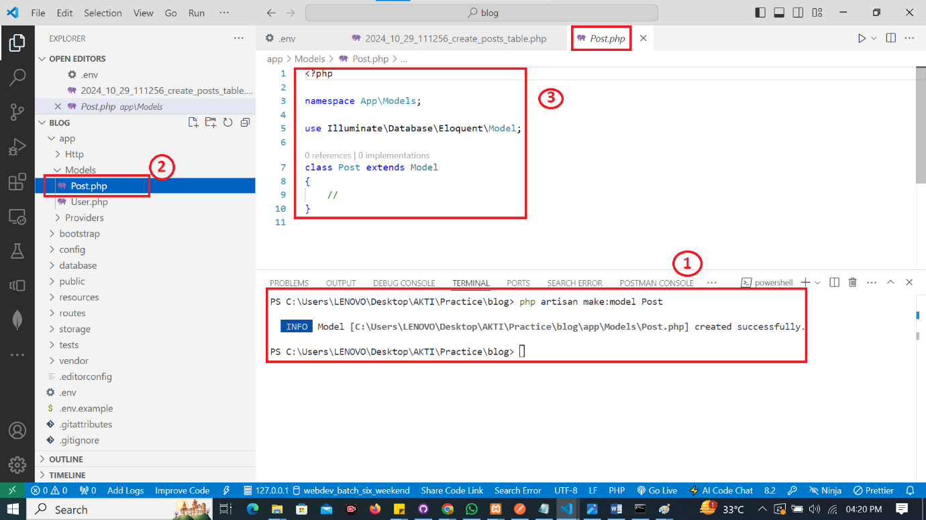

1. **Define Fillable Properties**
   * Open the Post.php model file in app/Models/ and add the following:

protected $fillable = ['title', 'content', 'author'];

**Step 5: Create a Controller**

1. **Generate the Controller**
   * Create a controller for handling post logic:

php artisan make:controller PostController --resource

* + **Screenshot**: After running the command.

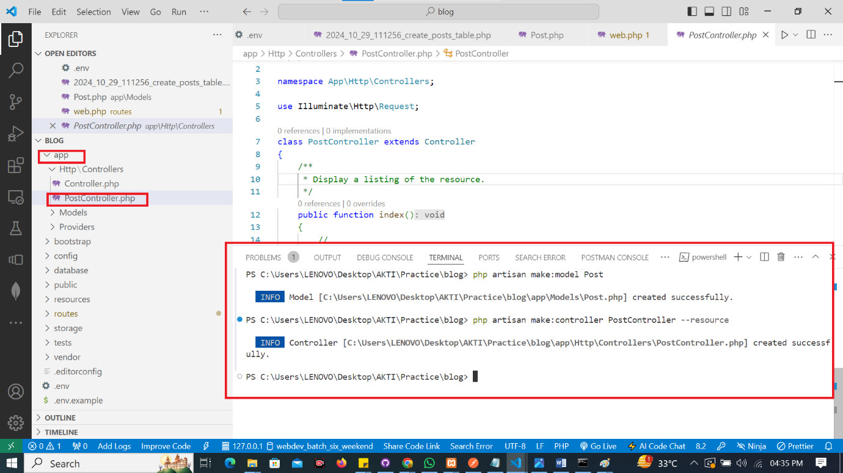

1. **Implement Controller Methods**
   * Open PostController.php in app/Http/Controllers/ and implement the necessary methods (index, create, store, show, edit, update, destroy).

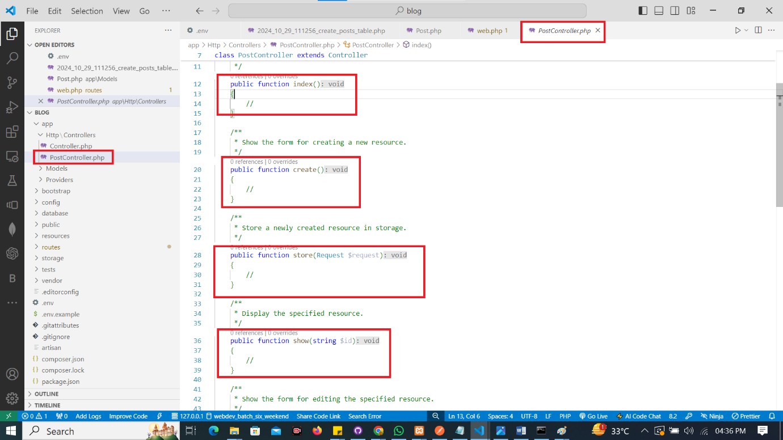

**Step 6: Define Routes for Blog Operation**

1. **Open Routes File**
   * Open routes/web.php.
2. **Add Routes**
   * Define the following routes:

Route::resource('posts', PostController::class);

* + **Screenshot**: web.php file with the new routes.

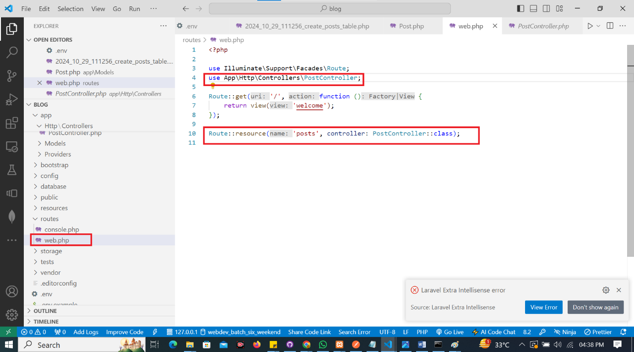

**Step 7: Create Views**

1. **Create Blade Templates**
   * Inside the resources/views directory, create a folder called posts.
   * Create the following Blade files:
     + index.blade.php for listing posts.
     + create.blade.php for the create form.
     + show.blade.php for displaying a single post.
     + edit.blade.php for editing a post.
2. **Example of index.blade.php**
   * **Screenshot**: index.blade.php file inside resources/view/posts folder

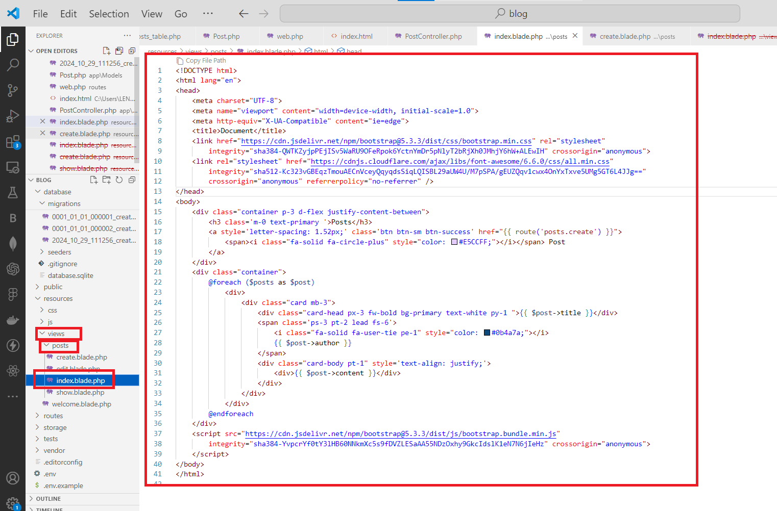

Add code in index method of PostController for viewing posts data from database.

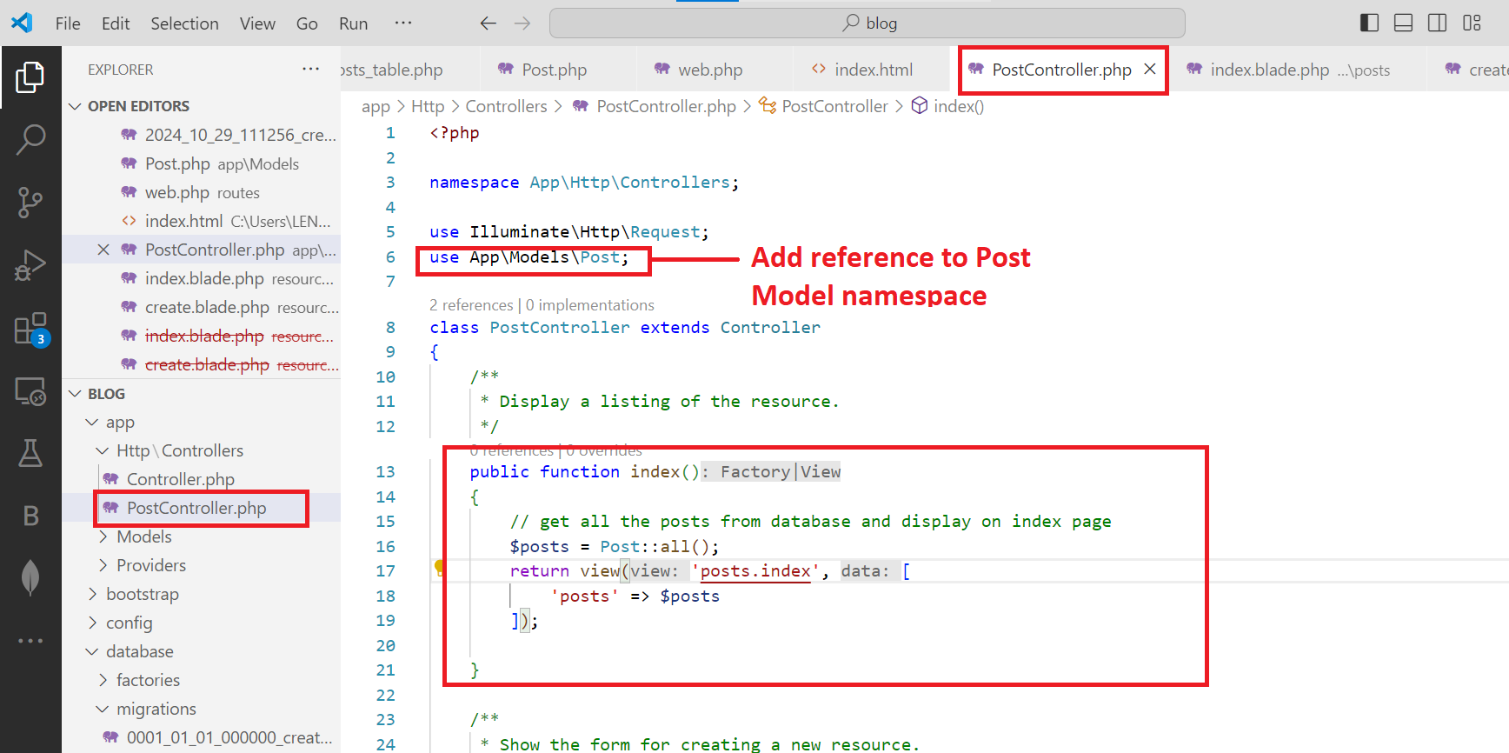

The posts in the blog_db are

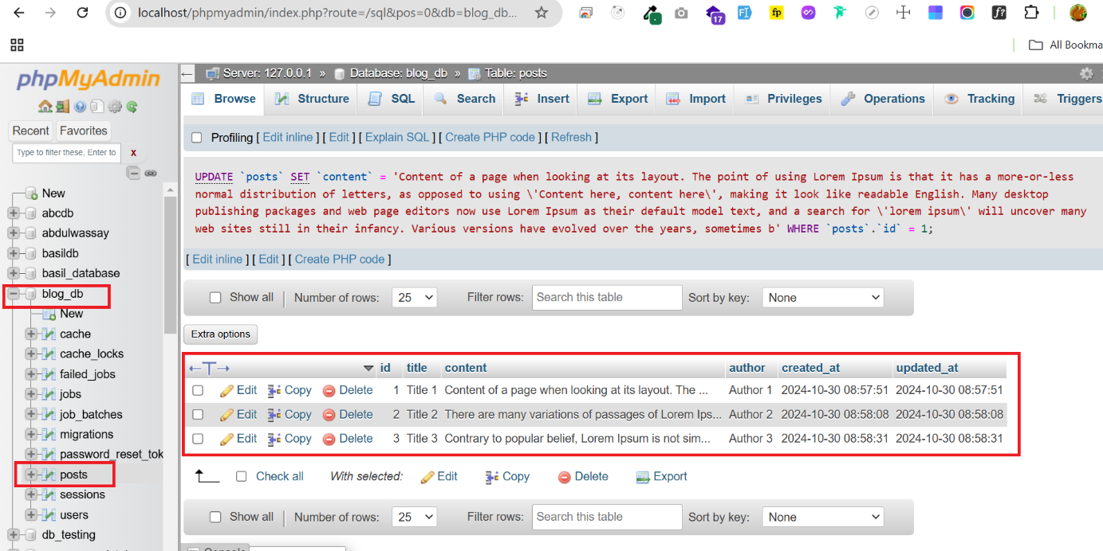

**Step 8: Test Your Application**

1. **Run the Development Server**

php artisan serve

1. **Access Your Application**
   * Open a web browser and navigate to http://localhost:8000/posts to view your blog posts.

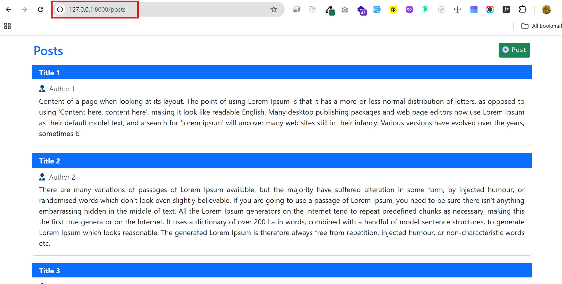

**Deliverables**

* Submit your Laravel project files in a zip format or share a Git repository link.